Money, Markets Final Assignment

SHORT ANSWER QUESTIONS

DO NOT PLAGIARIZE:

QUESTIONS

- Suppose you own $ 1 million of securitized paper backed by interest payments on various sorts of consumer loans. There are 5 tranches ranging from AAA to CCC; for simplicity, assume that each tranche represents 20% of face value. Obviously, each tranche has an expected annual default rate built in. The expected default rates range from 1% to 5% by tranche. When you bought, the $1 million represented an expected yield to maturity of 5%.
  - Now suppose that as the economy enters recession, the default rate on the CCC tranche rises to 15%. If you had planned to hold the asset for another 5 years, at what price (approximately) would you be happy to sell it for now? Show your calculations and explain your reasoning.
Face value for each tranch- 0.2*1000,000 = 200,000
Yield on each tranche= 200,000*0.05= 10,000
Loss on default = (0.04*210,000)+ 0.03*10,000)+(0.02*10,000)+(0.01*10,000)+( 0.15*10,000)

1,050,000-8800
=1041,200
  - Clearly, the market reaction in 2007-8 to a similar event was quite different. Why? Was that reaction justified?
There was market ineficieny and the investors did not have sufficient information about the future behavior of the market. As resuilt they reacted to speculations and investors rushed to buy stocks which later turned worthless as market crushed. Furthermore, the default on the mortgages affected all stanches of stocks, making them worthless and since the demand was low as market crushed, the investors could not sell.

- We are often told that “economic globalization” is a new phenomenon marking the contemporary world. (Unfortunately, “contemporary” is usually left undefined!)
One of our readings says:
“During the 1990s, a new phrase came into usage in discussions of the world economy: economic globalization. This term describes the possibility that the current international economy, comprising a network of economic ties binding otherwise relatively discrete national economies, may be transforming itself into a single, worldwide economy one in which national economies are no longer autonomous social arrangements.”

What objective data would you use to decide whether this alleged “globalization” was:
  - actually, taking place in a new and unprecedented way;

  - whether, were it to be the case, it would be a positive or negative occurrence and according to what metrics?
You must explain what data you would need to collect to decide the case one way or the other and how you would ensure that you have not missed any relevant considerations that might tip the balance the other way.
Economic globalization entails increased global economic engagements and decline in the production and trade autonomies. One of the data that I would collect to decide determine the case of economic globalization would be data on international trade in goods and services. The data on international trade in goods would tell the quantity and value of goods that have been traded between countries while the data on trade in services would detail the transactions in services between countries. This would tell whether countries are maintaining their economic autonomy, or world economic interdependence is increasing indicating economic globalization. Would also collect data on foreign direct investments. This form of international investment would point out the extend to which investors are gaining lasting interest in entities outside their countries. Increasing foreign direct investment globally would indicate a trend in which residents from one country are developing incr5eased interests in economic affairs and controls in other countries, hence pointing out that the national economies are no longer independent of social arrangements. Other forms of data that would be of interest in testing the hypothesis would be data on global value chain to measure globalization of production processes and foreign affiliate statistics to measure the extend of control of resident enterprises by foreign players.
If it were the case, it would be a positive occurrence. With the increasing would inequalities especially big gap between the poor and rich, developing and developed countries, economic globalization would be positive occurrence, as it would offer opportunities for residents in developing countries to work developed countries, and later invest in their countries. This would help foster economic development in poor countries and decrease wealth gap.
The trend would lead to increase in international agreements and fast movement of goods and services which would be beneficial to both developed and developing countries. Industries will grow as foreign investments robust. Global unemployment will decrease alongside poverty levels, which is beneficial for world economy. Under economic globalization, it will be feasible to acquire factors of production, and hence reduce the cost of production which will boost economic prices lowering inflation levels.

- (a) What is meant when we read about “financial globalization”? (b) From the standpoint of less developed countries seeking to improve their economic position, is financial globalization a good, bad or indifferent thing? In this regard, one of our readings says that:
“The welfare benefits of going from a situation without any capital mobility to a situation with completely free movement of capital is roughly equivalent to a one

Per cent increase in consumption for a typical emerging economy.2 One reason for the comparatively small estimated gains is that the low level of labor productivity associated with a low-income level seems not to be primarily the result of a lack of capital, but is dependent on other factors, such as poorly functioning institutions.”

C(c) Why is this remark largely beside the point? Explain.

Financial globalization is the integration of all world financial markets. Its act of creating global financial linkages through facilitation of a cross-border financial flows.
From the standpoint of less developed countries seeking to improve their economic position, the financial globalization is good thing. This is because financial globalization facilitates developing country’s ability to manage macroeconomic volatility, including capital mobility. Financial globalization increases capital mobility in developing countries which is vital for economic growth. It also increases country’s ability to regulate output and consumption volatilities, giving the states better control of their economic growth and reduced risks of financial and economic crisis.
This statement is beside the point because it asserts that low labor productivity and low-income levels are not primarily associated with lack of capital but other factors such as poorly functioning institutions. While I find it relevant that low functioning institutions may have role to play in the income and labor productivity levels, the capital availability plays a significant role. The availability and mobility of the capital is key economic determinant and can not be dissociated with economic performance.

- In 1993, Richard Thaler, one of the leading names in “behavioral finance”, co-founded an investment advisory business (Fuller & Thaler Asset Management) that is supposed to invest using the “principles of behavioral finance”.

It has not been especially forthcoming about its performance (which is not what you would expect if behavioral finance actually worked …). But the public record for its “Behavioral small-cap Equity fund” noticeably underperforms both the Nasdaq and the S&P500 price indices. Bear in mind that small cap equities should outperform the S&P

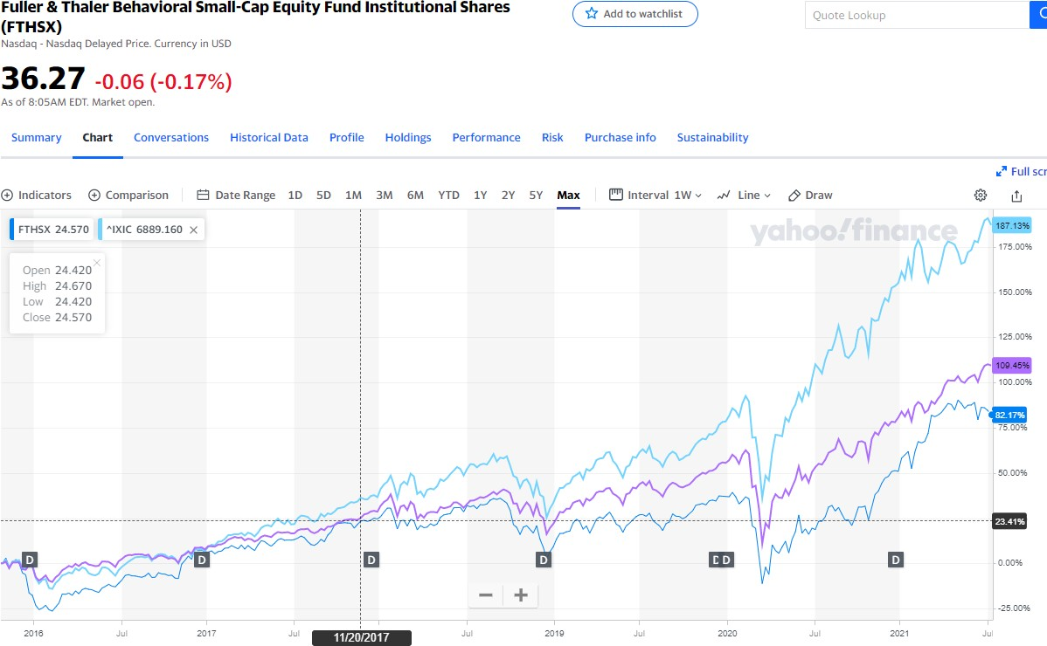

  - Clearly explain the “investing principles” of the EMH on one hand and of behavioral finance on the other.
One of the differences in the investing principles of the EMH and the behavioral finance is the rationality of the investors. The EMH holds that the investors are rational, and rationality of investors is most important consideration in financial market. On the other hand, the behavioral finance holds that investors are irrational and normal people. Also, the investors have emotional and psychological issues and biases that make them irrational. The EMH is also based on transparency of information. Investors have access to information. As result of informational efficiency, the markets will get to equilibrium. It also holds that no operational cost. This is not the case with the behavioral finance. Information is interpreted and understood differently by the people according to behavioral finance due to different cognitive capabilities and states. Different investors can have different effects on the market unlike EMH that holds single investor can’t have effect on market.

  - What does this data tell us about the viability of behavioral finance as a critique of the EMH? explain.
The underperformance of the Fuller & Thaler Asset Management’s Behavioral small-cap Equity fund tells us that behavioral finance can’t be considered perfect alternative of the EMH. As a critique of the EMH, its expected to perform well and have higher indexes. This is not reflected in reality, hence showing its ineffectiveness.

- There are conspiracy theories on the right, and there are conspiracy theories on the left. Of Goldman Sachs, Matt Taibbi writes:

“The bank’s unprecedented reach and power have enabled it to turn all of America into a giant pump-and-dump scam, manipulating whole economic sectors for years at a time, moving the dice game as this or that market collapses, and all the time gorging itself on the unseen costs that are breaking families everywhere — high gas prices, rising consumer credit rates, half-eaten pension funds, mass layoffs, future taxes to pay off bailouts. All that money that you’re losing, it’s going somewhere, and in both a literal and a figurative sense, Goldman Sachs is where it’s going: The bank is a huge, highly sophisticated engine for converting the useful, deployed wealth of society into the least useful, most wasteful and insoluble substance on Earth — pure profit for rich individuals.
Test the accuracy of Taibbi’s claims about the nefarious conduct of Goldman Sachs by a thorough analysis of any one of the assertions above (e.g., that Goldman Sachs is responsible for high gas prices).
In testing the Taibbi’s claim, I will examine the claim that Goldman Sachs is responsible for gas prices. The United States depends largely on foreign oil that is traded and priced globally. However, the actual price of the oil and its products is not only depended on the acquisition and prevailing economic conditions, but also future forecasts inform of speculations by such firms as Morgan Stanley and Goldman Sachs which sells oil-based commodity index funds. As sch firms as Goldman Sachs continue to make speculations about oil futures and sale more open crude oil futures contracts on their commodity future trading business, the oil prices surge, as it was the case in 2008. This takes the price of oil outside demand and supply forces, to mere speculations by futures commodity traders. From this perspective and analysis, I stand with Taibbi’s assertion.

- Bond markets are generally considered to be the main alternative to the stock market. In other words, in tough times in the stock market, investors are normally understood to move funds into the bond market. Higher interest rates are supposed to signal a stock market downturn and so forth. Can you confirm, disprove or explain this standard view using market data?

I confirm the statement that the bond market is generally conside3red to be the main alternative to the stock market. This is because the bond market is less risk and more efficient compared to the bond market. The reason behind this is because unlike the stock market, the bond market has fewer volatile returns, as the effect of economic factors like interest rates on the stock market is higher than bond market. The yield on the stock market become uncertain during tough times due to the fluctuating interest rates, and the increase in the interest rates signals diminished returns to the investors. This is the reason why the investors would consider bond market as an alternative to the stock market. For instance, while there was a significant drop in the volume of equities traded between 2019/2020 by $3 billion, the US corporate bond issuance increased to $1.919tn setting a record, which surpassed the previous record of $1.916 set in 2017. The steadiness in the income of the bonds makes them more preferable than stocks during tough times like last year.

- “Robo-advisors” (Wealth Simple, Wealth Bar etc.), the new alternative to mutual funds, seem to be fairly popular with new investors. As a rule, they claim to apply “artificial intelligence” to deliver the investor a “tailored portfolio”. But a substantial body of research has shown that very few mutual fund managers can “beat the index” after fees. Do robot-advisors do any better?
Robo advisors do not do any better. The robo advisors are not particularly designed to beat the market but to make portfolio performance in a way that is sync to the general market index. Robo advisors will only trade when its necessary to keep the portfolio in alignment with market index (Haegele, 2021). This indicates that its even harder to beat the market with the robo advisors than it is with the mutual fund managers. However, the robo-advisors would result into a more stable and higher return on investment than human managed portfolios. Research has shown that Robo-advisors outperform human managers in portfolio management by 2%. Robo advisors will produce a better-rounded portfolio that will less likely be volatile during bad economic times, hence more stable returns.

- Is the U.S. stock market in a bubble? How do you decide? I expect you to support your answer with empirical data.
The stock bubble is characterized by stock price surges that’s triggered by exuberant market behavior. The stocks within bubble trade at price that is higher than their intrinsic value. I would say that the U.S stock market is in bubble. As at end of April 2021, these S&P 500 SPX had +0.13% and traded at price earnings ratio or 37, a level that has never been wasted since 1998. The S &P 500 also moved up by 2% by May indicating surging prices (Carlson, 2021). Even though not all the companies went high during past few years like the Peloton which saw decline in its stocks from $150-$105, majority of the firms in the market have experienced surges. Companies like Facebook which had combined sales of $290 by time it went public on 2012 has grown its sales to more than 310% in the last 9 years. The interest rates in US are also in their generational lows in the decade, and 83.4% of companies are reporting stronger than expected profits in their second quarters (Levisohn, 2021).

Hegel B. (2021, August 15). Do robo-advisors beat the market? Modest Money. https://www.modestmoney.com/do-robo-advisors-beat-the-market/
Carlson, B.. (2021, May 2). The U.S. stock market SHOULD be in a bubble. https://awealthofcommonsense.com/2021/05/the-u-s-stock-market-should-be-in-a-bubble/
Levisohn, B. (2021, August 7). The stock market is a bubble. How it might deflate—in a good way. Barron's | Financial and Investment News. https://www.barrons.com/articles/stock-market-bubble-2021-51628296340

